Delayed Subject

✅ What is Delayed Subject
# Source: AI Source: Provided by: [Data Path: Persons Table -> ID Column: 1, Name_En Column: Motasem Essam] -> From: [Chatgpt (GPT-4-turbo)] on [8/4/2025]
A delayed subject is a construction where the true subject of the sentence appears after the verb, while a dummy "it" is placed in the subject position to introduce the sentence.
It often follows the pattern:
It + linking verb + [clause or infinitive phrase (true subject)]

🔹 Why Use It?
# Source: AI Source: Provided by: [Data Path: Persons Table -> ID Column: 1, Name_En Column: Motasem Essam] -> From: [Chatgpt (GPT-4-turbo)] on [8/4/2025]
- To improve sentence flow
- To make long or complex subjects easier to process
- To emphasize the subject at the end of the sentence

🔹 Structure Pattern:
# Source: AI Source: Provided by: [Data Path: Persons Table -> ID Column: 1, Name_En Column: Motasem Essam] -> From: [Chatgpt (GPT-4-turbo)] on [8/4/2025]
It + [be/linking verb] + [delayed subject clause or phrase]

🔹 Examples:
# Source: AI Source: Provided by: [Data Path: Persons Table -> ID Column: 1, Name_En Column: Motasem Essam] -> From: [Chatgpt (GPT-4-turbo)] on [8/4/2025]
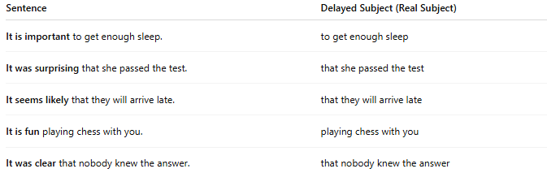
Sentence | Delayed Subject (Real Subject)
It is important to get enough sleep. | to get enough sleep
It was surprising that she passed the test. | that she passed the test
It seems likely that they will arrive late. | that they will arrive late
It is fun playing chess with you. | playing chess with you
It was clear that nobody knew the answer. | that nobody knew the answer

🔍 How to Spot a Delayed Subject:
# Source: AI Source: Provided by: [Data Path: Persons Table -> ID Column: 1, Name_En Column: Motasem Essam] -> From: [Chatgpt (GPT-4-turbo)] on [8/4/2025]
- Starts with "It"
- Verb often follows: is, was, seems, appears, becomes
- The real subject is delayed, usually in the form of:
  - An infinitive phrase: To learn English...
  - A gerund phrase: Running daily...
  - A noun (nominal) clause: That he lied...

🔁 Compare:
# Source: AI Source: Provided by: [Data Path: Persons Table -> ID Column: 1, Name_En Column: Motasem Essam] -> From: [Chatgpt (GPT-4-turbo)] on [8/4/2025]
Normal Subject Order:
👉 To finish the project on time is important.
Delayed Subject Order:
👉 It is important to finish the project on time.

